

**UNITED INTERNATIONAL UNIVERSITY**

LAB REPORT- 08

Course Name: Control System Laboratory

Course Code: EEE 402/ EEE 4110 (A)

**Submitted To;**

RAHMAN, KALED MASUKUR

PROFESSOR

UIU

**Submitted By;**

Name: Monisha Roy

ID: 021-182-031

Name: Joyanta Debnath

ID: 021-182-032

Date of Submission:

**Experiment Name:** Design of Feedback Compensator using Root Locus Method and SISO design tool.

**Objective:**

* Understanding PID Controller.
* Familiarity with Root Locus Method.
* SISO Design Tool Proficiency.
* Plant Modeling and Transfer Functions.
* Engineering Decision-Making Skills.

**Design Requirement:** Given, a unity feedback system is  And, H(s)=1. The PID controller should meet the following criteria;

1. Compensated settling time = 1/4 of uncompensated settling time
2. % OS = 20%

**(i)Uncompensated condition:** Plant and compensator= and the dominant poles at; -1.81+j3.53.

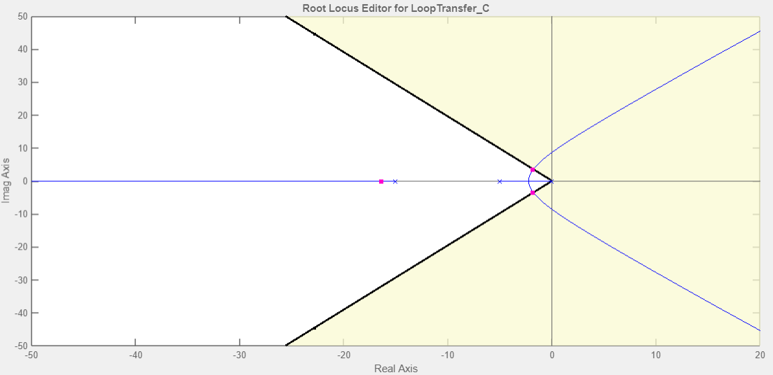

|  |  |  |  |  |  |  |  |  |  |
| --- | --- | --- | --- | --- | --- | --- | --- | --- | --- |
| K | ζ | ωn | %OS | Ts | Tp | Kv | e(∞) | Other Poles | Zeros |
| 258 | 0.456 | 3.97 | 19.3 | 2.16 | 0.968 | 3.44 | 0.29 | -16.4 | None |

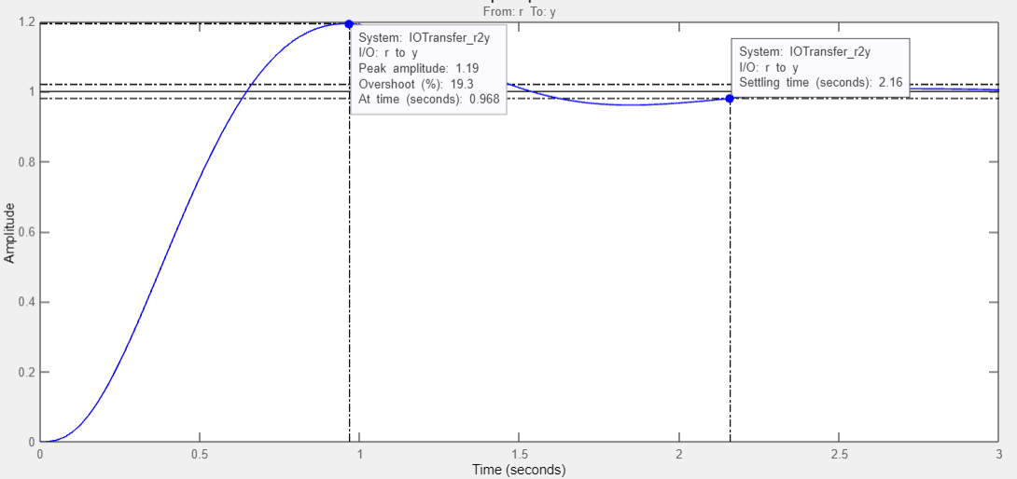

**(ii)PD compensated condition:** Plant and compensator= and dominant poles at; -7.24+j14.1.

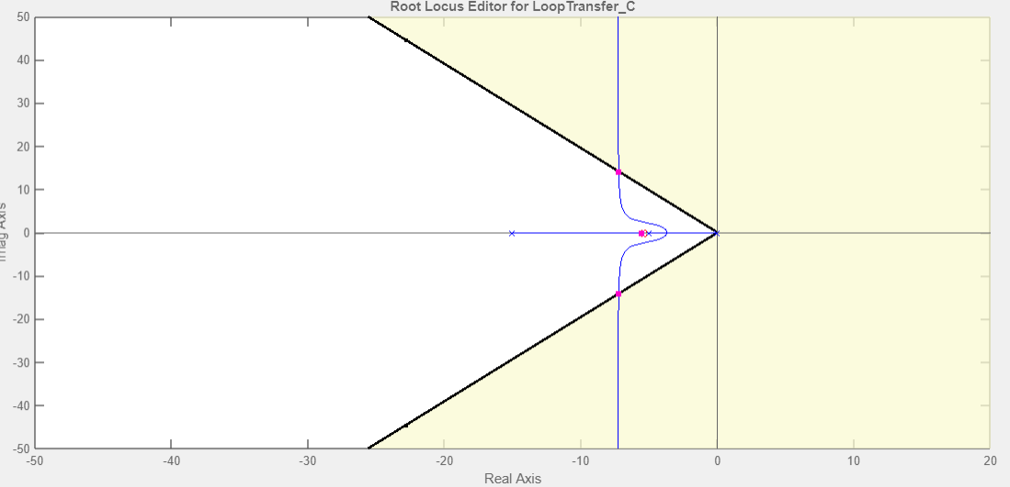

|  |  |  |  |  |  |  |  |  |  |
| --- | --- | --- | --- | --- | --- | --- | --- | --- | --- |
| K | ζ | ωn | %OS | Ts | Tp | Kv | e(∞) | Other Poles | Zeros |
| 257 | 0.456 | 15.9 | 21.2 | 0.522 | 0.223 | 18.54 | 0.053 | -5.51 | -5.41 |

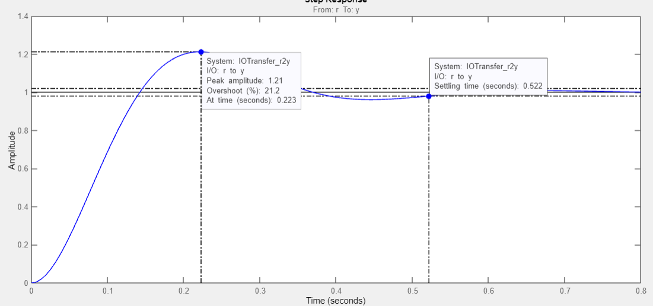

**(iii)Approach-1 compensated condition:** plant and compensator=**** and H(s) = 0.184s+1 with dominant poles at; -7.24+j14.1.

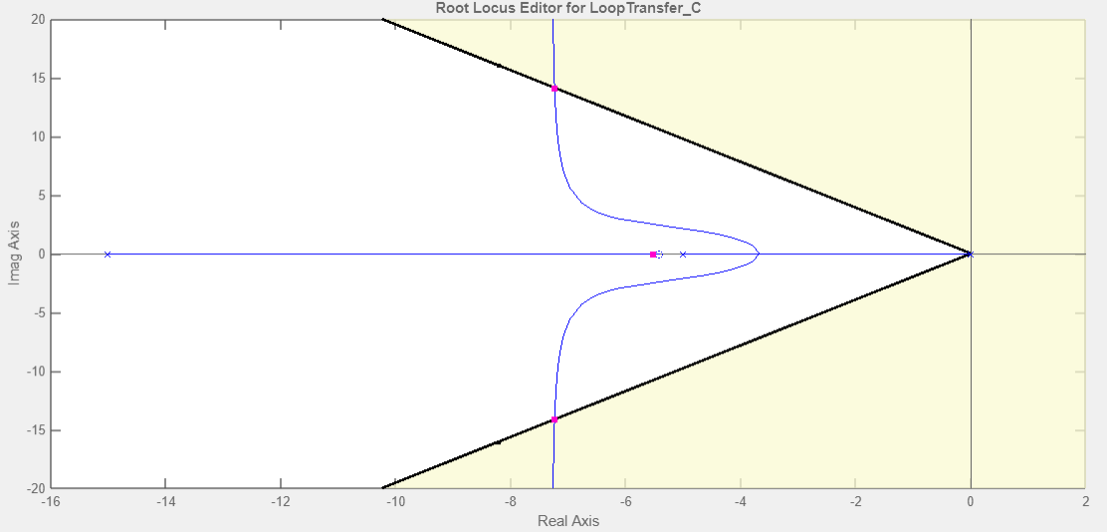

|  |  |  |  |  |  |  |  |  |  |
| --- | --- | --- | --- | --- | --- | --- | --- | --- | --- |
| K | ζ | ωn | %OS | Ts | Tp | Kv | e(∞) | Other Poles | Zeros |
| Kf=1/5.414  K1= 1391 | 0.456 | 15.9 | NA | 0.741 | NA |  |  | -5.51 | NONE |

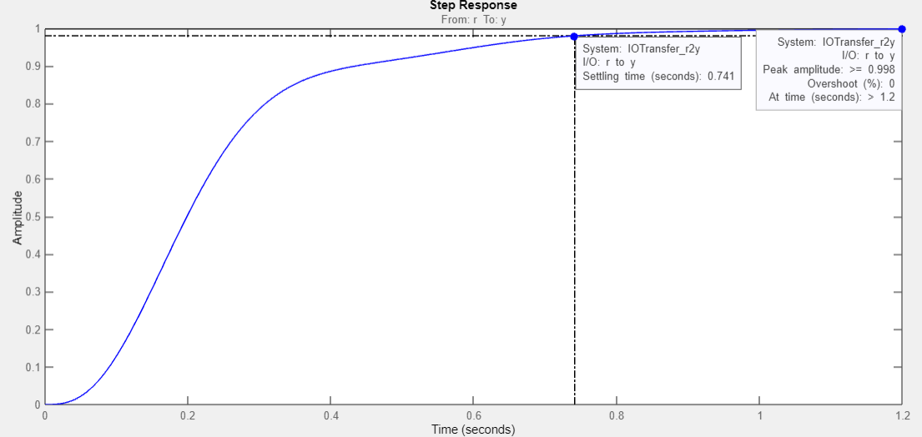

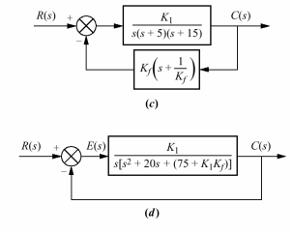**Feedback A1 compensator:**

**Discussion:**

|  |  |  |
| --- | --- | --- |
| COMPENSATOR: | **PD** | **Feedback A1** |
| 1. Zero | Forward path | Feedback path |
| 1. T(S) | Zero in N(S) | No zero |
| 1. Noise sensitivity | High | Low |
| 1. Speed | High (Higher settling time) | Low |

**(iv)Approach-2 compensated condition:** Plant and compensator= and H(s) = 0.184s+1 where,

(1) a damping ratio of 0.8 for the minor loop and (2) a damping ratio of 0.6 for the closed loop system.

|  |  |  |  |  |  |  |  |  |  |
| --- | --- | --- | --- | --- | --- | --- | --- | --- | --- |
| K | ζ | ωn | %OS | Ts | Tp | Kv | e(∞) | Other Poles | Zeros |
| Kf=81.25  K1=624.3 |  |  |  |  |  |  |  |  |  |



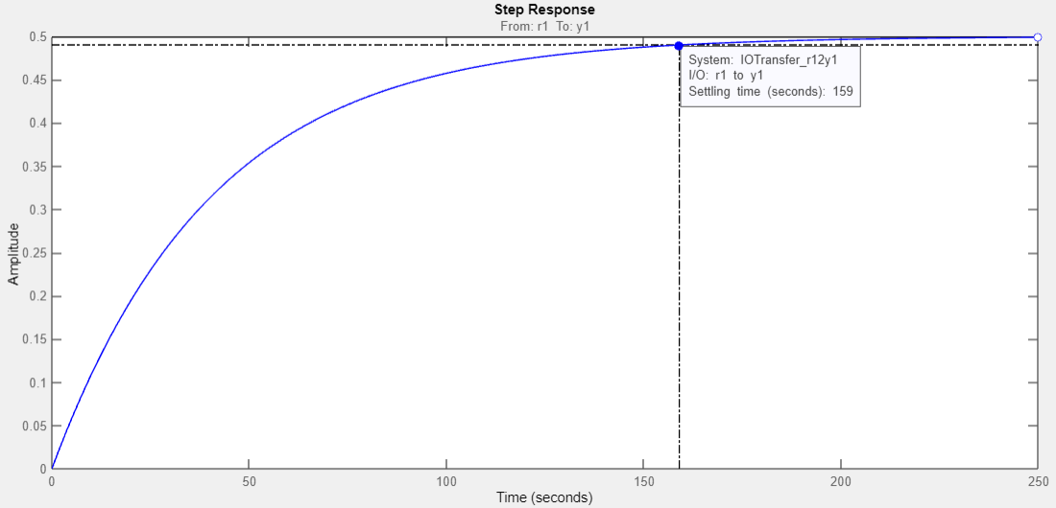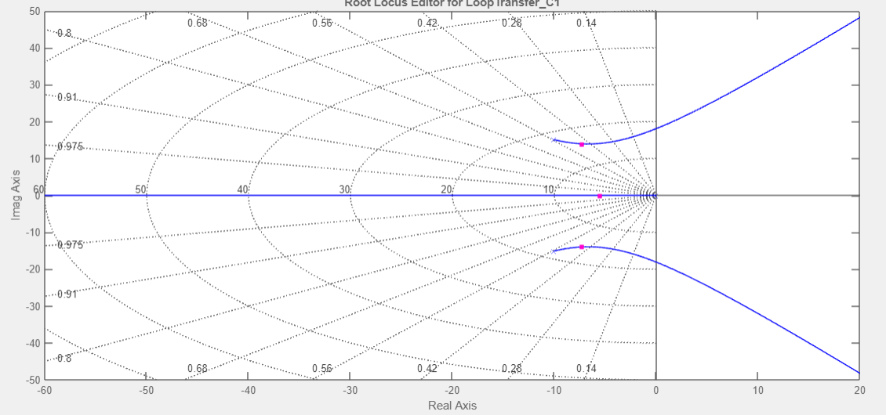

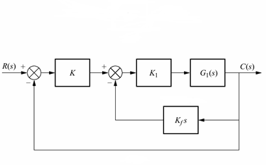**Feedback A-2 compensator:**

**Discussion:**

* **Damping ratio change in Feedback**: Here we can see maximum deviation of the system's response from its steady-state values. Increasing Kv tends to increase the percent overshoot and minimizes Ts in Feedback compensation. Moreover, in Feedback compensation following the third pole domination, it is hard to maintain required damping ratio, thus increase in Ts has been noticed.
* **Acceptability**: Weather or not this Feedback compensator is accepted, is highly dependent on the application of the controller. Although, Ts is much lower in Feedback compensation but in terms of response, PD compensation is faster than Feedback. Feedback has less noise sensitivity.
* **Trial and Error**: As we failed to maintain required damping ratio both minor loop and closed loop. Varying Kf in closed loop we can achieve targeted values.